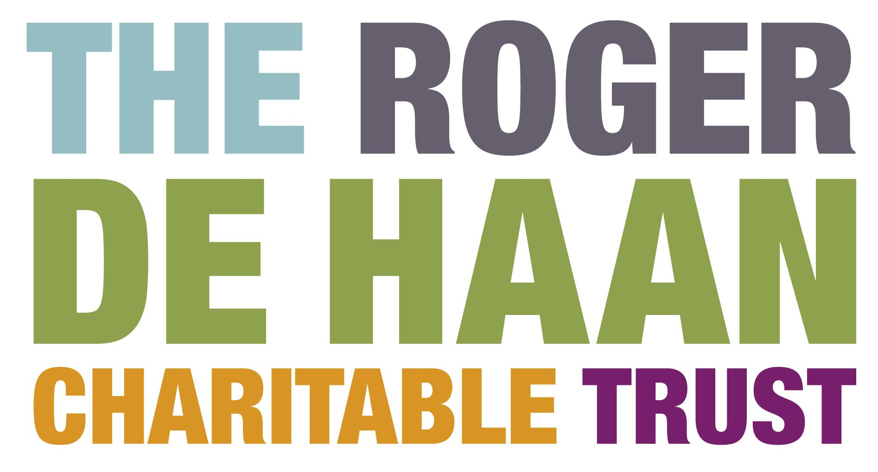

Festivals Fund

Creative Folkestone is a visionary arts charity dedicated to supporting the regeneration of Folkestone through creative activity. Working with the people of Folkestone, partners and stakeholders we aim to transform the town making it a better place to live, work, visit and study.

Creative Folkestone believes in the power of creativity to transform people, places and communities. We are passionate about this and believe it will inspire others to be curious and imagine a changed future.

As part of this transformation, the two Boards of Trustees of the Roger De Haan Charitable Trust and Creative Folkestone have agreed to establish a Festivals Fund to encourage new festivals and artistic activities centred around Folkestone’s Creative Quarter for the benefit of the community and visitors to the town.

Grants are available up to £5,000. Applications will be considered from arts groups, companies, organisations or sole traders based in the Folkestone area with aspirations to develop new and exciting festivals with community involvement. The festival can be thematic or issue-based but the outcome must be creative and for a live audience. The fund will not support digital projects, one-off exhibitions or performances.

We are taking positive action to achieve equal opportunities in our work and welcome applications from people of any race, nationality, ethnic origin, religion, socio-economic background, marital status, sex, sexual orientation, age or disability. We actively encourage those who feel marginalised or are currently under-represented in the arts to apply.
The selection panel will use the following criteria when assessing applications:

- An exciting, original, creative idea.
- Demonstration of a practical and achievable delivery plan.
- Evidence of community engagement.
- A realistic approach to finance and evaluation.
- A sound marketing and PR campaign.
- A commitment to diversity and equal opportunity.

There are three deadlines for applications as follows :

5pm on 4 February 2022 for projects starting between 1 April – 31 August 2022
5pm on 14 April 2022 for projects starting between 1 September – 31 December 2022
5pm on 29 July 2022 for projects starting between 1 January – 31 March 2023

Payments will be issued between 1 April 2022 and 31 March 2023. Please email Cheryl Pierce, Head of Performing Arts & Learning, Creative Folkestone if you have any questions cherylpierce@creativefolkestone.org.uk

Festivals Fund Application Form

YOU ARE INVITED TO RESPOND TO THE QUESTIONS IN THIS SECTION EITHER IN WRITING OR WITH A SHORT VIDEO/SOUND FILE. We do not have a format preference and the recorded version should have the same content as if it were written. No assessment of the production quality of audio or video recordings will be made.

1. | Name of lead applicant
2. | Name of festival
3. | Name of your organisation, company or group if applicable
4. | How are you or your group formally constituted?
5. | Address
6. | Contact telephone number
7. | E-mail address
8. | How much money are you applying for (up to £5,000)?
8. | When will your festival or project take place?
9. | Where will your project take place?
10. | Tell us about yourself and your experience of managing events (max 250 words)
11. | Please provide a description of your festival or project (max 250 words)
12. | Please describe how you will manage the festival or project (max 250 words)
13. | How many people do you hope to attract as audience?
14. | How many people do you hope to involve overall and how will they take part?
15. | Please describe your marketing & PR campaign (max 250 words)
16. | What is the total cost of your project? Please provide a simple budget
17. | What other funding do you have or hope to have in place?
18. | How will you evaluate the success of your festival or project? (max 250 words)
19. | Please tell us who the payment will be made out to if your application is successful

Signed by lead applicant: Date:

Please email your completed application form, or send a link, along with the attached Equal Opportunities Monitoring Form by the appropriate deadline to Cheryl Pierce cherylpierce@creativefolkestone.org.uk

We aim to assess applications and inform you of the outcome within 2 weeks.

Creative Folkestone, Quarterhouse, Mill Bay, Folkestone, Kent CT20 1BN
www.creativefolkestone.org.uk
registered charity no: 1105174
company no: 4566484

