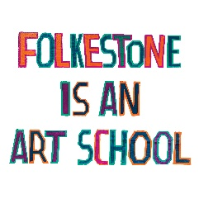
Folkestone Triennial ‘The Plot’ 2021
Workshop Proposal Form

Thank you for your interest in the Folkestone Triennial Workshop Call out. We are looking for a broad idea of what you want to do and may contact you for more information if needed.

Once you have completed this form please send, via email to liv@livpennington.com with ‘Triennial Workshop Proposal’ in the subject line. The deadline for proposals is midday, 12 July 2021.

As well as this completed form, please provide any additional information you think might be useful; documentation of your work, examples of the workshop taking place (if available), a risk assessment etc.

Your full name(s):
Company name: | Leave blank if this isn’t applicable
Contact Email:
Contact Phone:
Website address or any online documentation of your work (eg. social media): | Leave blank if this isn’t applicable
Workshop Title:
Public Liability | Yes / No
Current DBS | Yes / No

Please provide a brief outline of your workshop idea, and how it relates to ‘The Plot’ in no more than 200 words:

What type of location/ venue would be ideal? (please name a specific location/venue if possible)

Who is your ideal audience / who do you think this workshop will appeal to?

How much set up time would be ideal?

What materials will you require / be using?
What other requirements would you need (i.e. power supply, tables, chairs etc)

Ideally, what would be the duration / session times of the one-day workshop?

What would be your ideal capacity / number of attendees?

Are the workshops open/drop in or would you prefer people to prebook?
In terms of health & safety, what potential issues are there that we would need to be aware of and overcome? If you have one, please attach a risk assessment to your proposal.

