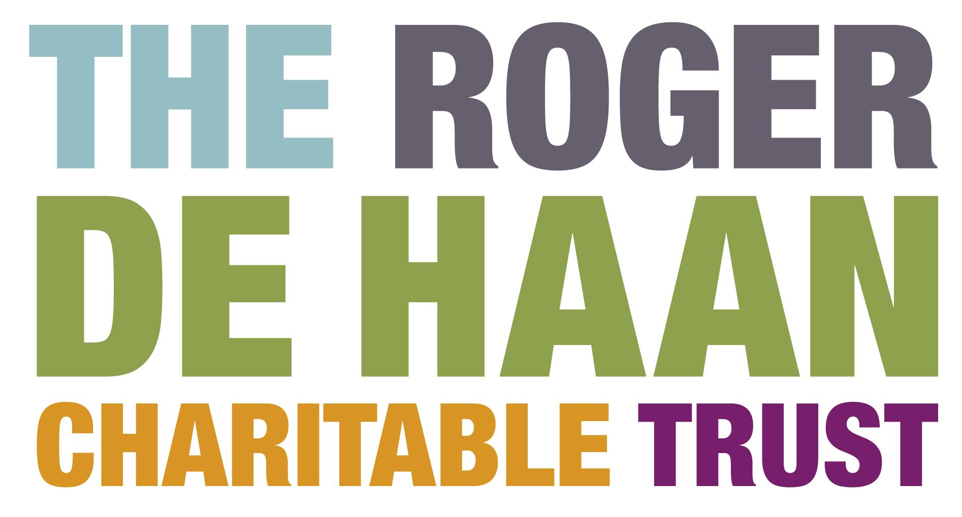

Festivals Fund

Creative Folkestone is a visionary arts charity dedicated to enabling the regeneration of Folkestone through creative activity. Working with the people of Folkestone, partners and other stakeholders we will transform the town making it a better place to live, work, visit and study.

Creative Folkestone believes in the power of creativity to transform people, places and communities. We are passionate about this and believe it will inspire others to be curious and imagine a changed future. We will enable and collaborate with them to make this vision happen. This will be fun and requires knowledge. At times we will be radical and push boundaries, but we will take on the challenge and risks our work demands.

Established in 2002 Creative Folkestone has a remarkable record of success having already transformed the more run down part of Folkestone into a Creative Quarter populated by artists and home to creative industries and a university. 300 jobs have been created and 90 buildings have been restored in the Creative Quarter and Quarterhouse, a performance venue for music, theatre, dance and comedy has been built. The area has been animated by two internationally acclaimed visual art Triennials, a collection of significant and permanent contemporary public art, a full performance programme and an annual book festival.

Creative Folkestone is driven by a smart and friendly work force, led by a knowledgeable and dedicated voluntary board, guided by Chairman Roger De Haan’s vision and sustained by the philanthropy of his family’s CharitableTrust. The two Boards of Trustees of the Roger De Haan Charitable Trust and Creative Folkestone have agreed to establish and administer respectively a fund to encourage new festivals and artistic events. The purpose is to enliven and animate the arts scene in and around the old town and encourage participatory events for the benefit of the community and visitors alike. It is anticipated that projects will benefit from seed-corn funding to help realise projects that have merit and that might otherwise struggle to reach fruition. It is not envisaged that this should be the sole funding source.
Applications will be considered from arts groups or organisations based in the Folkestone area with aspirations to develop:
• New and exciting festival ideas based around the Creative Quarter and harbour
• Artistic displays or exhibitions by local groups
• Live performance or street animation
The selection panel may use some or all of the following criteria when assessing applications:
Demonstration of a sound, practical delivery plan.
How support and volunteers will be mobilised to contribute to the event.
Evidence of community engagement.
A sensible approach to finance and evaluation.
A sound marketing and PR campaign that aims to reach your target audiences.

Grants are available up to £5,000.00 per project. Please fill in the form below and return it to Creative Folkestone. Please also enclose or attach any supporting material that demonstrates the experience and expertise of your organisation or community group. The panel will only consider culture related (music, theatre, performance, visual arts etc) projects, festivals and events and not any sport initiatives. Please note that we will not consider applications for events that will take place within 3 months of the date the application reaches us.
1. | Name of Charity/Group
2. | Is your organisation a registered charity?
3. | If yes, what is your registration number?
4. | If you are not a registered charity, how is your group formally constituted?
5. | Are you part of a larger organisation? If so, what is the name of your parent organisation?
6. | Details of contact person for this application - Name:
7. | Address:
8. | Daytime telephone number:
9. | E-mail address:
10. | Please provide a brief description of your project  (plan and delivery)
11. | Please explain why you are applying for a fund and how you would use it
12. | Which geographical area and community will benefit from your project and how many people do you expect to attract?
13. | What is the planned duration of the project for which funds are sought?
14. | What is the total cost of your project?
15. | What is the amount of funding you are requesting from us?
16. | What funding do you have in place so far and from what sources?
17. | Who else have you approached for funding?
18. | How will you evaluate the project?
19. | Please indicate from the menu below the marketing & PR tools you will use to promote your event and describe your campaign:  - Press release to local, regional & national press  - Website  - Social media  - Advertising in local and regional press  - Advertising in local radio  - Leaflet/brochure  - Posters  - Banners in town  - E-flyers  - Other (please specify)

If you are not a registered charity, please attach a copy of your constitution if applicable.

Name:

Signed: Date:

We will only use any data you provide for the purposes of this application. It will remain confidential and will not be shared with any other body.

Please return your completed application form to: ioannisioannou@creativefolkestone.org.uk

or by post to:
Ioannis Ioannou
Head of Marketing & Engagement
Creative Folkestone
Quarterhouse
Mill Bay
Folkestone
CT20 1BN

If you have any queries re any of the above please call Ioannis on 01303 760 744. As soon as we receive your application form and supporting material, we will send you a confirmation of receipt and we will get in touch with you within a month with our final decision. There is no timetable for applications, and the selection panel will meet as required, but please endeavour to apply at least three months in advance of the proposed date of the planned project.

